**Create dynamic webapp**

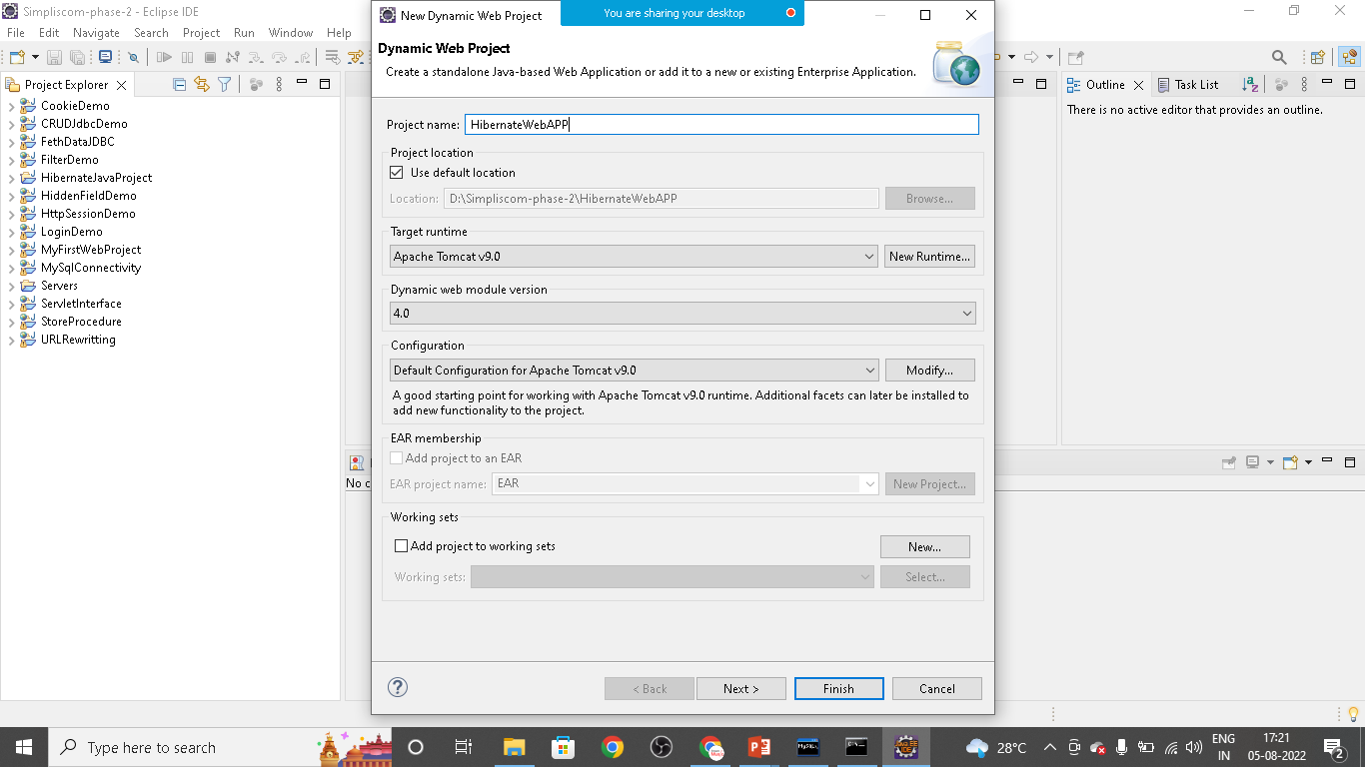

**Create** index.html **file**

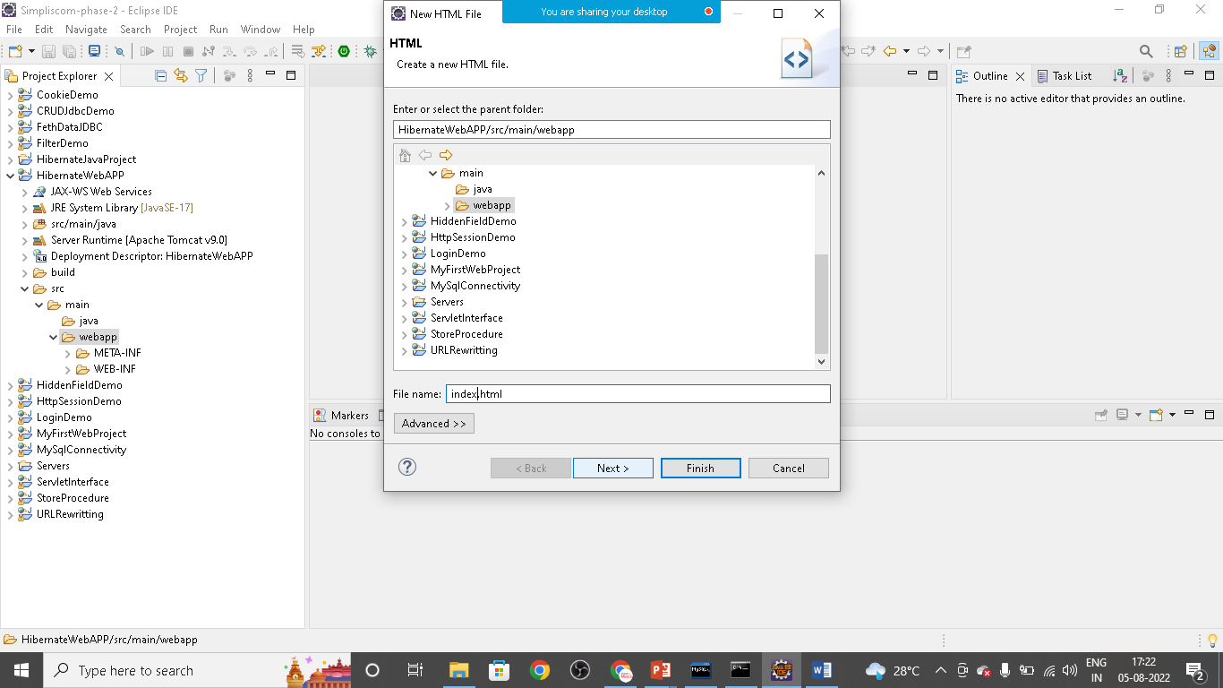

Index.html

<!DOCTYPE html>

<html>

<head>

<meta charset=*"ISO-8859-1"*>

<title>Insert title here</title>

</head>

<body>

<h1>Welcome to Hibernate Web APP</h1>

<br>

<a href=*"init"*>Test Connection</a>

</body>

</html>

**Src>main>webapp>WEB-INF>lib>copy all hibernate jar file and mysql connector jar files**

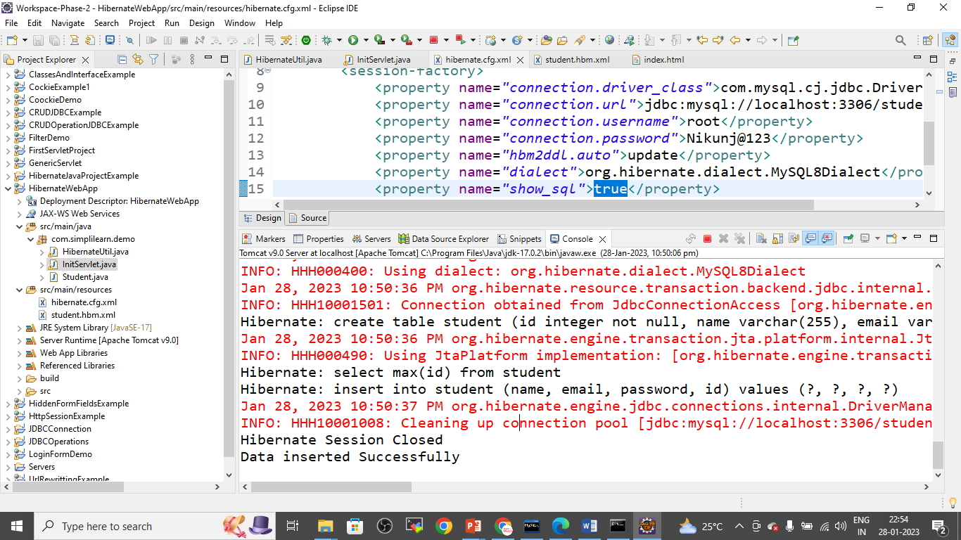

Create **initServlet** to handle init request from html

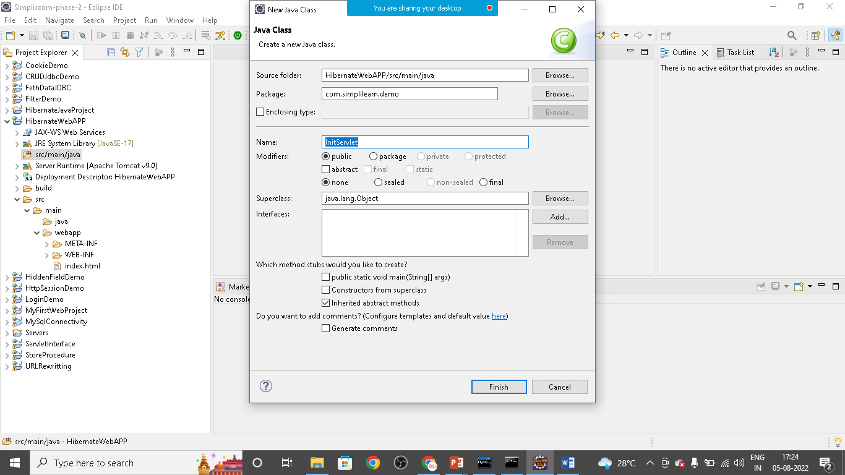

Init servlet

package com.simplilearn.demo;

import java.io.IOException;

import java.io.PrintWriter;

import javax.servlet.ServletException;

import javax.servlet.annotation.WebServlet;

import javax.servlet.http.HttpServlet;

import javax.servlet.http.HttpServletRequest;

import javax.servlet.http.HttpServletResponse;

import org.hibernate.Session;

import org.hibernate.SessionFactory;

import org.hibernate.Transaction;

@WebServlet("/init")

public class InitHibernate extends HttpServlet {

private static final long serialVersionUID = 1L;

protected void doGet(HttpServletRequest request, HttpServletResponse response) throws ServletException, IOException {

PrintWriter out= response.getWriter();

//connection pool

SessionFactory factory= HibenateUtil.getSessionFactory();

// connection

Session session= factory.openSession();

out.println("Hibernate Session Opened");

Student s1= new Student();

s1.setName("Rorisang");

s1.setEmail("rorisang@gamil.com");

s1.setPassword("rs@123");

Transaction tx=session.beginTransaction();

session.save(s1);

tx.commit();

//automatically table created in db and data inserted in the same

session.close();

factory.close();

out.println("Hibernate Session closed");

System.out.println("Data Inserted Successfully");

}

protected void doPost(HttpServletRequest request, HttpServletResponse response) throws ServletException, IOException {

// TODO Auto-generated method stub

doGet(request, response);

}

}

Create **HibernateUtil** class

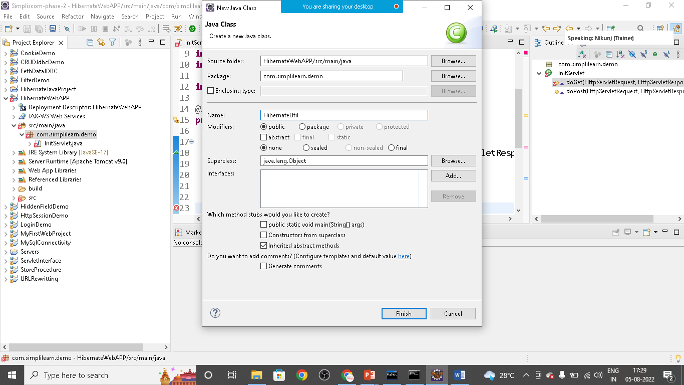

package com.simplilearn.demo;

import org.hibernate.SessionFactory;

import org.hibernate.boot.Metadata;

import org.hibernate.boot.MetadataSources;

import org.hibernate.boot.registry.StandardServiceRegistry;

import org.hibernate.boot.registry.StandardServiceRegistryBuilder;

public class HibenateUtil {

private static SessionFactory sessionFactory;

static {

try {

StandardServiceRegistry registry= new StandardServiceRegistryBuilder().

configure("hibernate.cfg.xml").build();

Metadata metadata= new MetadataSources(registry).getMetadataBuilder()

.build();

sessionFactory= metadata.getSessionFactoryBuilder().build();

}

catch(Exception e){

}

}

public static SessionFactory getSessionFactory() {

return sessionFactory;

}

}

Create **resource** folder

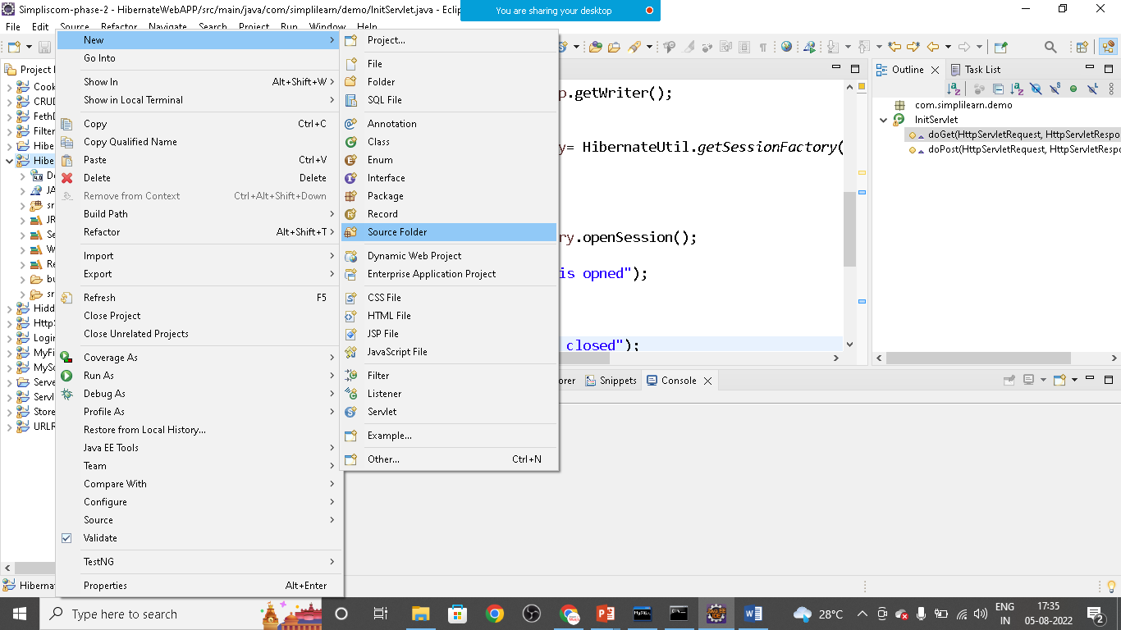

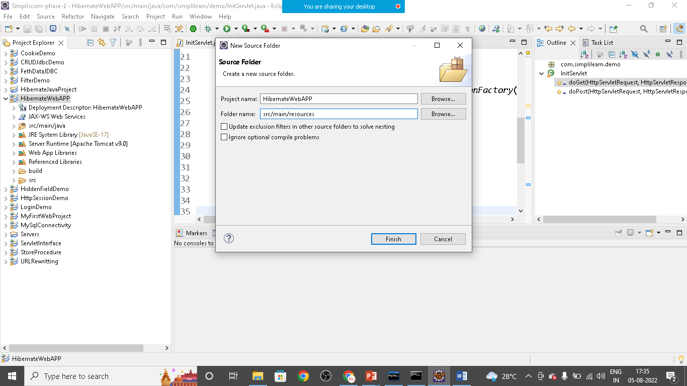

Create

1. hibernate.cgf.xml
2. student.hbm.xml

Hibernate.cfg.xml

<?xml version=*"1.0"* encoding=*"UTF-8"*?>

<!DOCTYPE hibernate-configuration PUBLIC

"-//Hibernate/Hibernate Configuration DTD 3.0//EN"

"http://www.hibernate.org/dtd/hibernate-configuration-3.0.dtd">

<hibernate-configuration>

<session-factory>

<property name=*"connection.driver_class"*>com.mysql.cj.jdbc.Driver</property>

<property name=*"connection.url"*>jdbc:mysql://localhost:3306/student</property>

<property name=*"connection.username"*>root</property>

<property name=*"connection.password"*>Nikunj@123</property>

<property name=*"hbm2ddl.auto"*>update</property>

<property name=*"dialect"*>org.hibernate.dialect.MySQL8Dialect</property>

<property name=*"show_sql"*>true</property>

<mapping resource=*"student.hbm.xml"*/>

</session-factory>

</hibernate-configuration>

Student.hbm.xml

<?xml version=*"1.0"* encoding=*"UTF-8"*?>

<!DOCTYPE hibernate-mapping PUBLIC

"-//Hibernate/Hibernate Mapping DTD 3.0//EN"

"http://www.hibernate.org/dtd/hibernate-mapping-3.0.dtd">

<hibernate-mapping package=*"com.simplilearn.demo"*>

<class name=*"Student"* table=*"student"*>

<id name=*"id"* column=*"id"*>

<generator class=*"increment"*></generator>

</id>

<property name=*"name"* type=*"string"*></property>

<property name=*"email"* type=*"string"*></property>

<property name=*"password"* type=*"string"*></property>

</class>

</hibernate-mapping>

Add jar files to the library folder

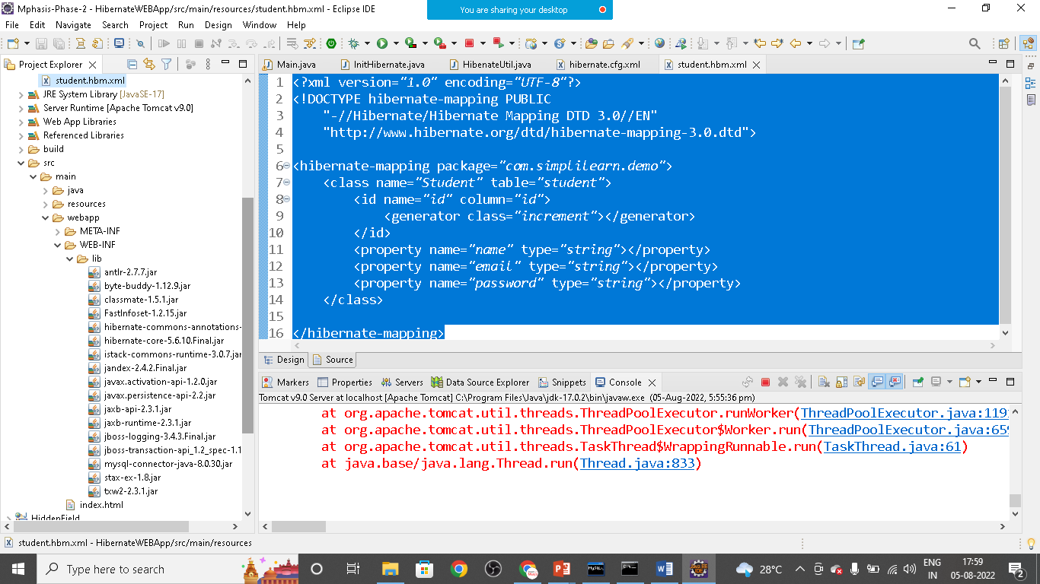

Save the project and run on server

